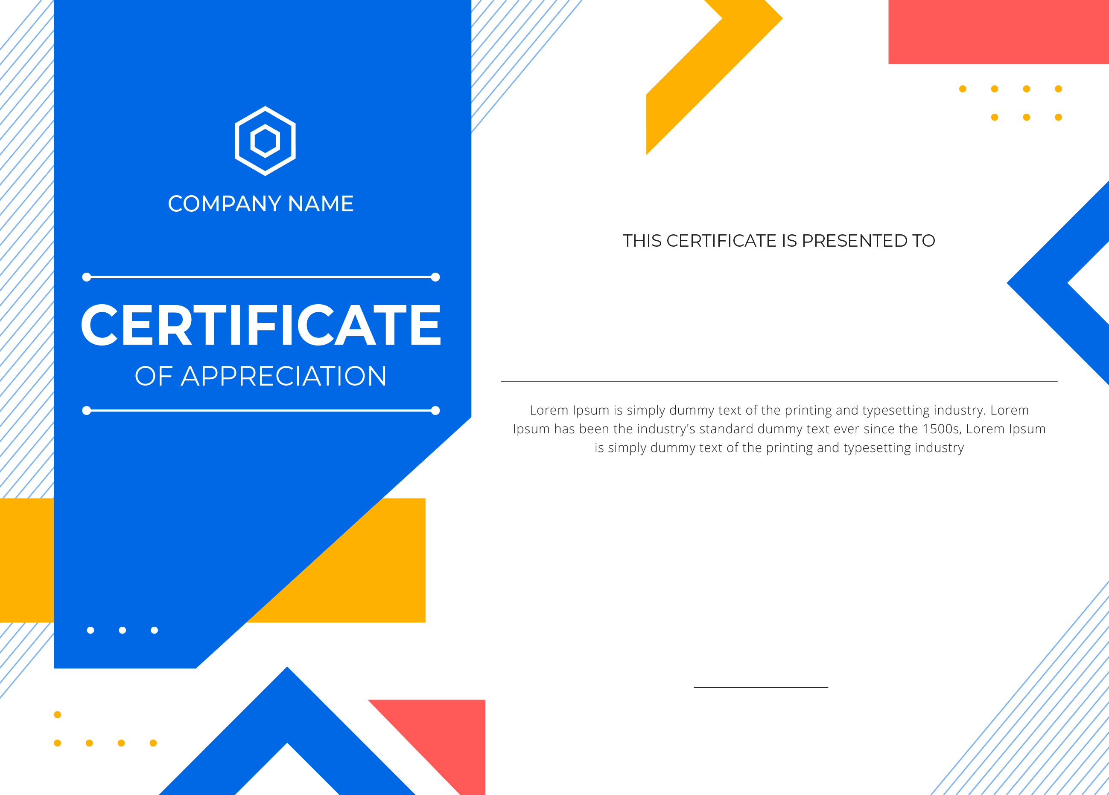

valeria dias

ANSHUMAN